Caecilian

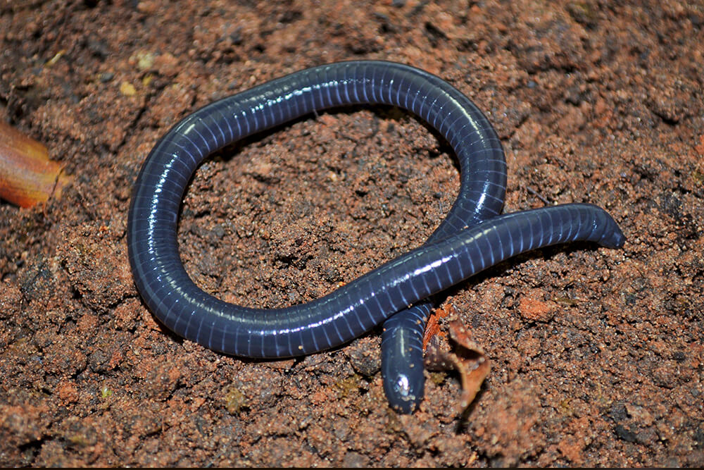

Caecilians completely lack limbs, making the smaller species resemble worms, while the larger species, with lengths up to 1.5 m (5 ft), resemble snakes. Their tails are short or absent, and their [cloacae](https://en.wikipedia.org/wiki/Cloaca) are near the ends of their bodies.[[2]](https://en.wikipedia.org/wiki/Caecilian#cite_note-2)[[3]](https://en.wikipedia.org/wiki/Caecilian#cite_note-3)[[4]](https://en.wikipedia.org/wiki/Caecilian#cite_note-Brittanica-4)

Their skin is smooth and usually dark, but some species have colourful skins. Inside the skin are [calcite](https://en.wikipedia.org/wiki/Calcite) [scales](https://en.wikipedia.org/wiki/Scale_(zoology)). Because of these scales, the caecilians were once thought to be related to the fossil [Stegocephalia](https://en.wikipedia.org/wiki/Stegocephalia" \o "Stegocephalia), but they are now believed to be a secondary development, and the two groups are most likely unrelated.[[4]](https://en.wikipedia.org/wiki/Caecilian#cite_note-Brittanica-4) The skin also has numerous ring-shaped folds, or annuli, that partially encircle the body, giving them a segmented appearance. Like some other living amphibians, the skin contains glands that secrete a toxin to deter predators.[[5]](https://en.wikipedia.org/wiki/Caecilian#cite_note-EoR-5) The skin secretions of *Siphonops paulensis* have been shown to have [hemolytic](https://en.wikipedia.org/wiki/Haemolysis" \o "Haemolysis) properties.[[6]](https://en.wikipedia.org/wiki/Caecilian#cite_note-6)

Caecilians' vision is limited to dark-light perception,[[7]](https://en.wikipedia.org/wiki/Caecilian#cite_note-7) and their anatomy is highly adapted for a burrowing lifestyle. They have a strong skull, with a pointed snout used to force their way through soil or mud.[[4]](https://en.wikipedia.org/wiki/Caecilian#cite_note-Brittanica-4) In most species, the bones in the skull are reduced in number and fused together, and the mouth is recessed under the head. Their muscles are adapted to pushing their way through the ground, with the skeleton and deep muscles acting as a piston inside the skin and outer muscles. This allows the animal to anchor its hind end in position, and force the head forwards, and then pull the rest of the body up to reach it in waves. In water or very loose mud, caecilians instead swim in an eel-like fashion.[[5]](https://en.wikipedia.org/wiki/Caecilian#cite_note-EoR-5) Caecilians in the family [Typhlonectidae](https://en.wikipedia.org/wiki/Typhlonectidae" \o "Typhlonectidae) are aquatic, and the largest of their kind. The representatives of this family have a fleshy fin running along the rear section of their bodies, which enhances propulsion in water.[[8](https://en.wikipedia.org/wiki/Caecilian#cite_note-8)